SUIT reference protocol RP2_AmR pce
O2k high-resolution respirometry

2016-11-21

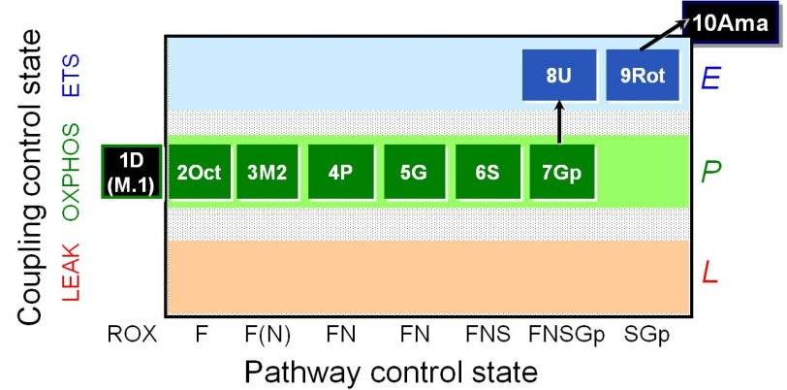
O2k and DatLab file: P___ ( A / B ) 2016- Operator:
Sample type: Cohort: Sample code:
Sample.Subsample number: Unit: Concentration:
Medium:
Event | Mark name  O2/Amp  Slope | Mark name  Amp  Signal | Final conc. 2 ml O2k | Stock  [mM] | Comment | Tit.  [µl] | A | B
MiR
O2 |  |  | ~200 µM
AmR |  |  | 10 µM | 10 |  | 2
HRP |  |  | 1 U/ml |  | 500 U/ml stock | 4
SOD | 0BL |  | 5 U/ml |  | 5000 U/ml stock | 2
 |  | 1HP0 | 0 |  | Mark on Amp signal
HP |  | 1HP.1 | 0.1 µM | 0.04 | Mark on Amp signal | 5
HP |  | 1HP.2 | 0.2 µM | 0.04 | Mark on Amp signal | 5
ce | R
Dig |  |  |  | 8.1
 |  | 2HP0 | 0 |  | Mark on Amp signal
HP |  | 2HP.1 | 0.1 µM | 0.04 | Mark on Amp signal | 5
1D | 1D |  | 2.5 mM | 500 |  | 10
M.1 | (M.1) |  | 0.1 mM | 50 |  | 4
2Oct | 2Oct |  | 0.5 mM | 100 |  | 10
3M2 | 3M2 |  | 2 mM | 400 |  | 9.5
4P | 4P |  | 5 mM | 2000 |  | 5
5G | 5G |  | 10 mM | 2000 |  | 10
6S | 6S |  | 50 mM | 1000 |  | 100
 |  | 3HP0 | 0 |  | Mark on Amp signal
HP |  | 3HP.1 | 0.1 µM | 0.04 | Mark on Amp signal | 5
7Gp | 7Gp |  | 10 mM | 1000 |  | 20
8U | 8U |  | Δ0.5 µM | 1 | CCCP | Δ1
9Rot | 9Rot |  | 0.5 µM | 1 |  | 1
10Ama | 10Ama |  | 2.5 µM | 5 |  | 1
 |  | 4HP0 | 0 |  | Mark on Amp signal
HP |  | 4HP.1 | 0.1 µM | 0.04 | Mark on Amp signal | 5

